Welcome!
Congratulations on purchasing the Liber809. This board was designed to mate the Motorola 6809E microprocessor to Atari 8-bit computer systems based on the 6502C microprocessor. It is a complete replacement and as such, requires complete removal of both the 6502C microprocessor and the ROM from the Atari motherboard.

What You Have
The following parts comprise the Liber809 product:

- The board with 68B09E and support chips installed
- A 40 pin machine socket attached to the bottom pins.
- 16K 27128 EPROM containing the Liber809 firmware.
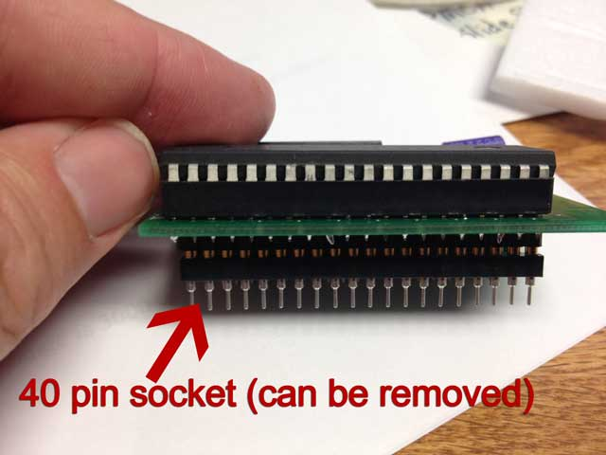
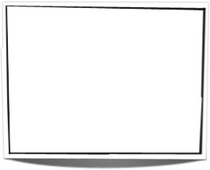
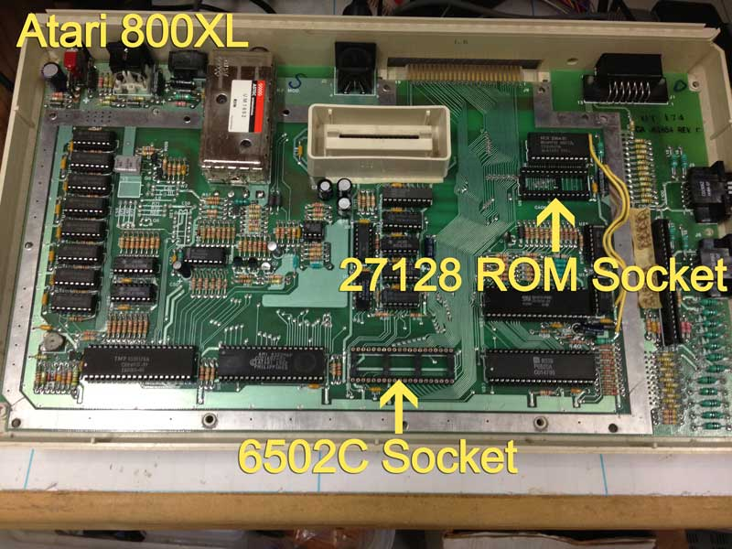
Note that the 40 pin machine socket can be removed, thought it is recommended to stay in place in order to protect the pins that are soldered to the board. In certain cases, however, clearance issues on certain systems will require you to remove the 40 pin socket. PLEASE TAKE CARE NOT TO BEND THE PINS SOLDERED TO THE BOTTOM OF THE LIBER809. PLUG AND UN-PLUG THE BOARD VERY CAREFULLY!

What You Need to Know
Installing the Liber809 on requires that both the CPU and the ROM on the motherboard be socketed. If this is not the case, then the CPU and ROM must be desoldered and sockets put in place. IF YOU DO NOT HAVE THE EXPERTISE TO DO THIS, THEN YOU SHOULD HAVE SOMEONE QUALIFIED TO DO THIS.

We’ve separated the installation instructions based on the type of system. Please determine the correct installation procedures for your system and follow them carefully.

Installation in the Atari 800XL
The Atari 800XL presents a very tight fit for the Liber809. Because of this, your Liber809 should have both the CPU and the support chip directly soldered onto the board, and you should REMOVE the 40 pin socket from the bottom of the Liber809 board. This is necessary because there is very little vertical clearance when the top case and keyboard are attached to the bottom case.

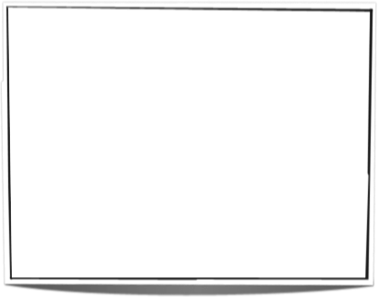
Since removing the 40 pin socket from the bottom of the LIber809 board is required, you MUST BE CAREFUL TO NOT TO BEND THE PINS ON THE UNDERSIDE OF THE LIBER809 BOARD! If you ever need to remove the Liber809 board for any reason, do so with care!

Installation in the Atari 1200XL

[PENDING]

Installation in the Atari 130XE
The Liber809 fits extremely well inside of the Atari 130XE. To install, unscrew and remove the top case, then carefully unplug the ribbon cable that connects the keyboard to the motherboard. A metal shield is fixed atop the motherboard and must be removed in order to continue. Using pliers, carefully twist the metal tabs around the edges of the metal shield until it can safely be removed.

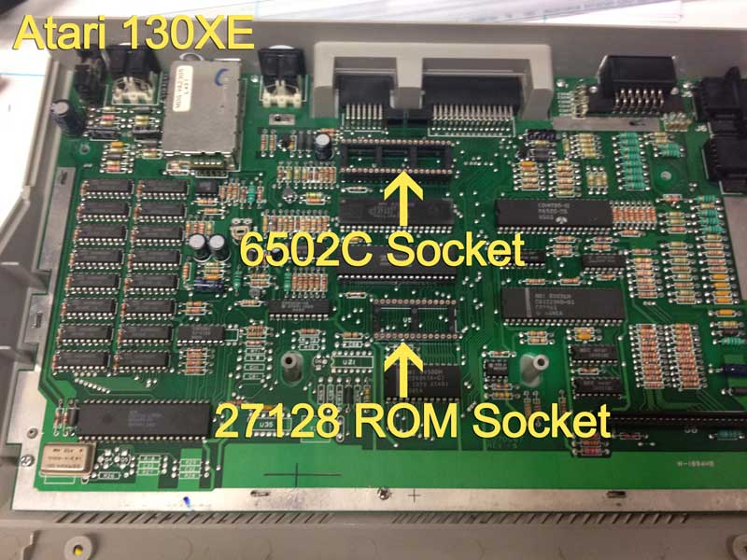
BE CERTAIN TO KEEP the 40 pin socket attached to the bottom pins of the Liber809 board. This not only protects the pins on the bottom of the Liber809 board, it also lifts the board enough to provide clearance from the surrounding case.

Remove the 6502C (SALLY) chip and the 16K ROM from their sockets, then install the Liber809 and 27128 EPROM in their place.

The metal shield cannot be reinstalled with the Liber809 installed, so simply put it aside.

Testing The Installation
Once you have completed the installation, reassemble your system them power it up. If all goes well, you should see the Liber809 boot screen appear. If you do not see this screen, check your connections and ensure that the board and ROM are snug.

Using DriveWire to boot NitrOS-9
The Liber809 firmware is setup to discover and load an application file called ‘kick’ which is served via DriveWire through the SIO port on the Atari. This requires you to have a device known as an SIO2PC, which connects the Atari to the USB port of a computer running DriveWire.

Once the SIO2PC device is connected, download DriveWire 4 (http://sites.google.com/site/drivewire4/). Once downloaded, then go to the Liber809 GitHub site and download both the ‘kick’ file and the NitrOS-9 bootfile (https://github.com/boisy/liber809/tree/master/atari/nitros9)

Copy both files into the same folder as DriveWire 4.

Now run DriveWire 4. You will be prompted for type of computer (select ‘CoCo 3’) and the serial port. Once setup is complete, load drive 0 with the NitrOS-9 disk you downloaded from GitHub.

Now turn on the Atari. The Liber809 firmware will mount the ‘kick’ file (which is actually a NitrOS-9 boot file), and NitrOS-9 will proceed to load on your Atari system.

